Planning My Day 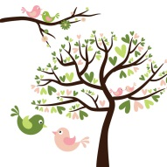

To Do List:

____________________ _____________________ ____________________  
____________________ _____________________ ____________________  
____________________ _____________________ ____________________  
____________________ _____________________ ____________________  
____________________ _____________________ ____________________

HAPPILYUNPROCESSED.COM

TIME BLOCKING:

6:00AM ___________________________________  
7:00AM ___________________________________  
8:00AM ___________________________________  
9:00AM ___________________________________  
10:00AM__________________________________  
11:00AM___________________________________  
12:00PM__________________________________  
1:00PM ___________________________________  
2:00PM ___________________________________  
3:00PM ___________________________________  
4:00PM ___________________________________  
5:00PM ___________________________________  
6:00PM ___________________________________  
7:00PM ___________________________________  
8:00PM ___________________________________  
9:00PM ___________________________________  
10:00PM __________________________________  
11:00PM __________________________________

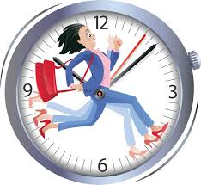

WHAT’S ON THE MENU:  
______________________  
______________________  
______________________  
______________________

TO CALL EMAIL OR TEXT:  
________________________  
________________________  
________________________  
________________________



NOTES:  
________________________  
________________________  
________________________  
________________________  
________________________  
________________________  
________________________